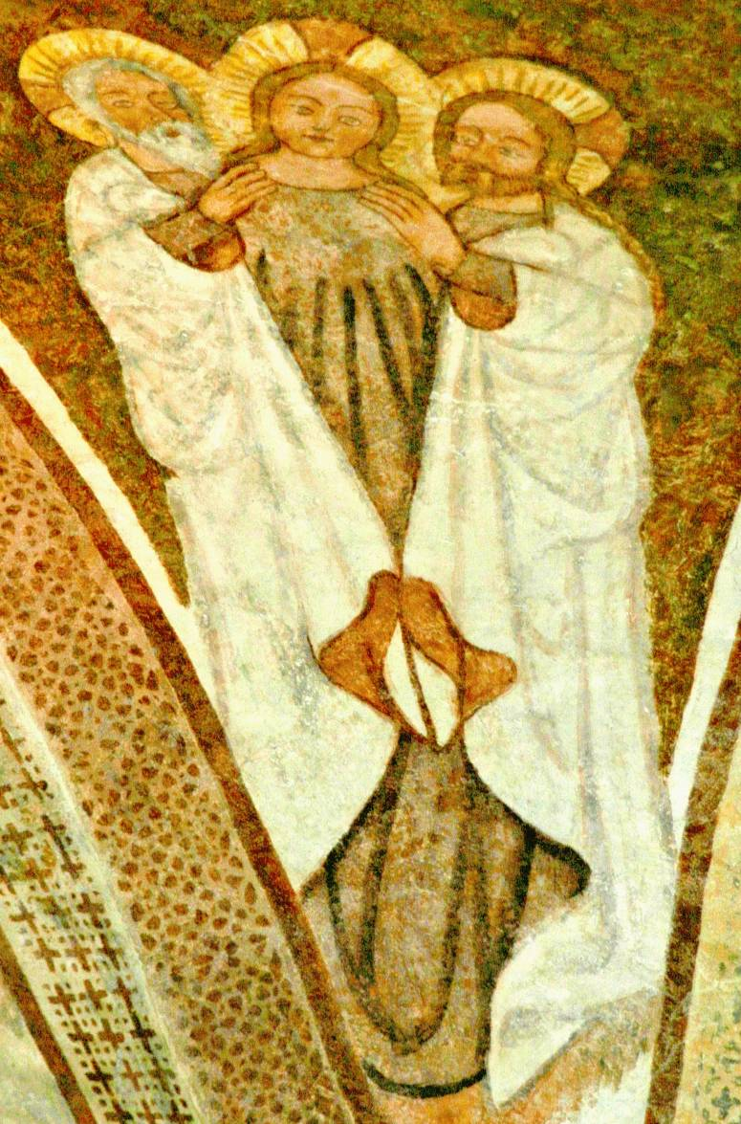

“The Trinity” “The Trinity”
Medieval Church Medieval Church
Urschalling, Bavaria Urschalling, Bavaria

